**SQL TASK IMPLEMENTATION QUERIES**

1.Ans:

SELECT FIRST_NAME AS WORKER_NAME FROM Worker;

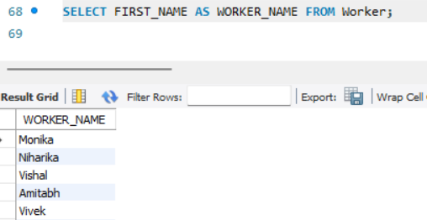

2.ANS:

SELECT UPPER(FIRST_NAME) AS FIRST_NAME_UPPER FROM Worker;

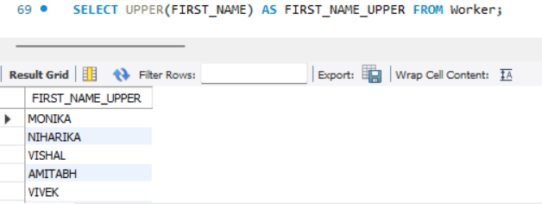

3.ANS:

SELECT distinct department from worker;

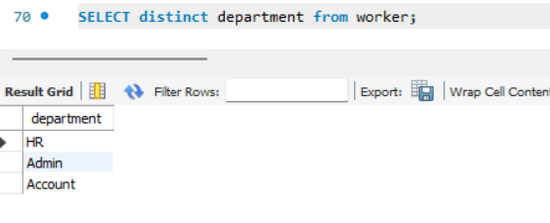

4.ANS:

select left(FIRST_NAME,3) as First_name_three from Worker;

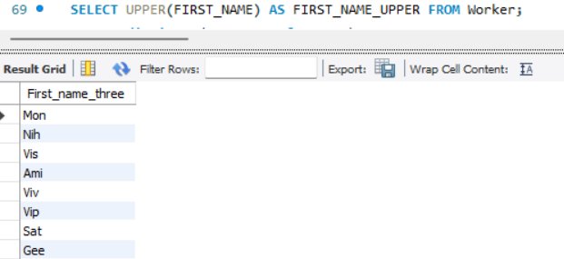

5.ANS:

SELECT INSTR(FIRST_NAME, 'a') AS POSITION_OF_A FROM Worker WHERE FIRST_NAME = 'Amitabh';

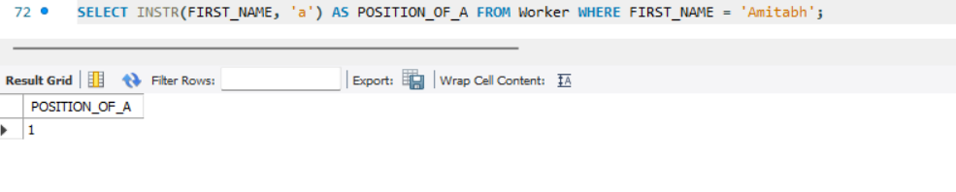

6.ANS:

SELECT RTRIM(FIRST_NAME) AS FIRST_NAME_WITHOUT_SPACES FROM Worker;

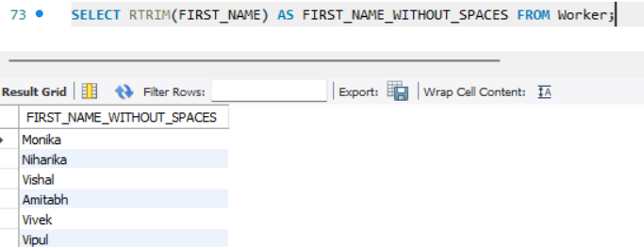

7.ANS:

SELECT LTRIM(DEPARTMENT) FROM Worker;

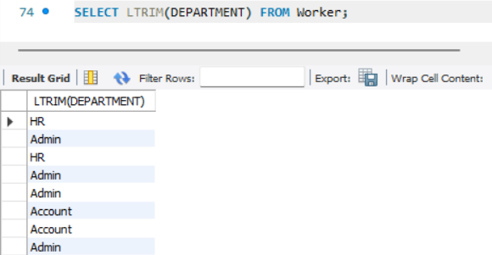

8.ANS:

SELECT DISTINCT DEPARTMENT, LENGTH(DEPARTMENT) AS DEPARTMENT_LENGTH FROM Worker;

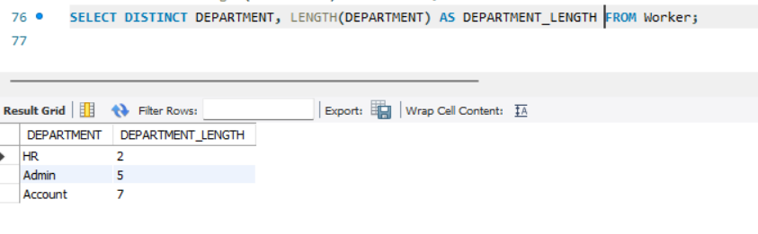

9.ANS:

SELECT REPLACE(FIRST_NAME, 'a', 'A') FROM Worker;

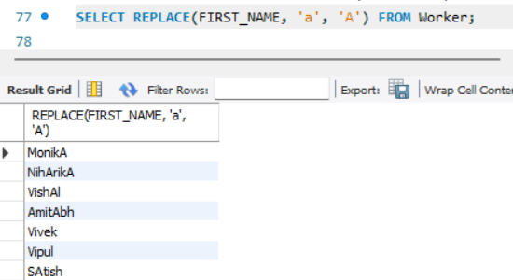

10.ANS:

Select CONCAT(FIRST_NAME, ' ', LAST_NAME) AS 'COMPLETE_NAME' from Worker;

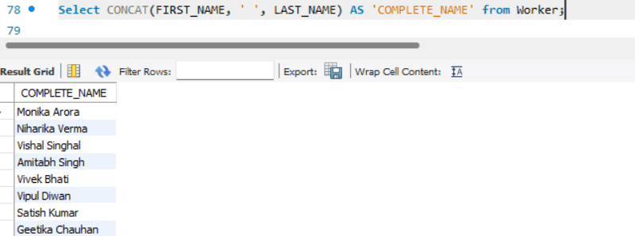

11.ANS:

Select * from Worker order by FIRST_NAME asc;

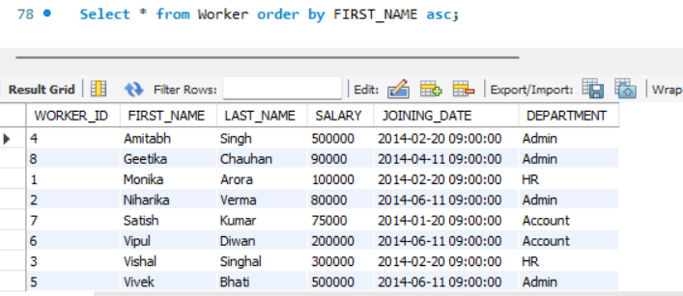

12.ANS:

SELECT * FROM Worker ORDER BY FIRST_NAME ASC, DEPARTMENT DESC;

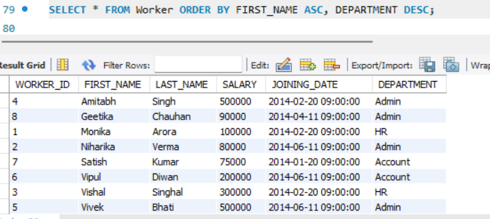

13.Ans:

SELECT * FROM Worker WHERE FIRST_NAME IN ('Vipul', 'Satish');

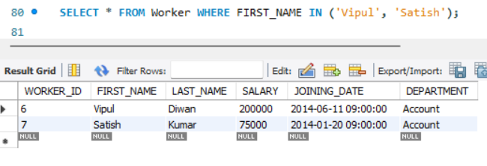

14.ANS:

SELECT * FROM Worker WHERE FIRST_NAME NOT IN ('Vipul', 'Satish');

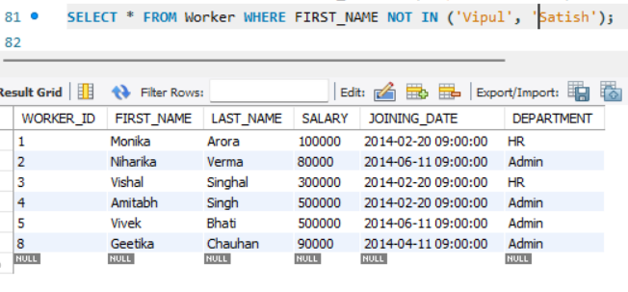

15.ANS:

SELECT * FROM Worker WHERE DEPARTMENT = 'Admin';

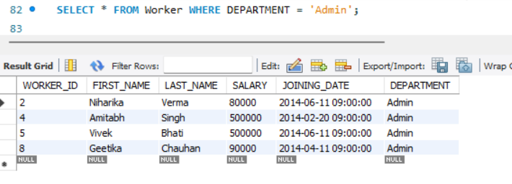

16.ANS:

SELECT * FROM Worker WHERE FIRST_NAME LIKE '%a%';

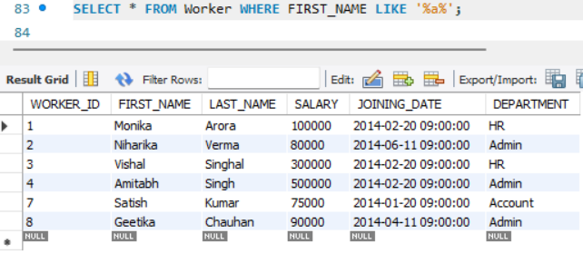

17.Ans:

SELECT * FROM Worker WHERE FIRST_NAME LIKE '%a';

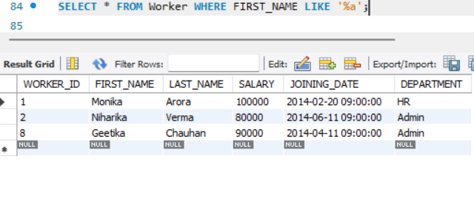

18.ANS:

SELECT * FROM Worker WHERE FIRST_NAME LIKE '%h' AND LENGTH(FIRST_NAME) = 6;

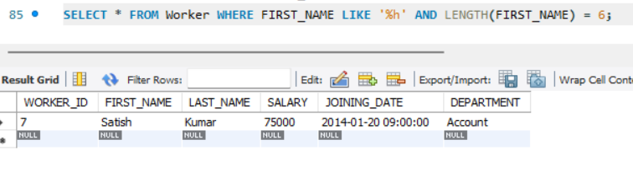

19.Ans:

SELECT * FROM Worker WHERE SALARY BETWEEN 100000 AND 500000;

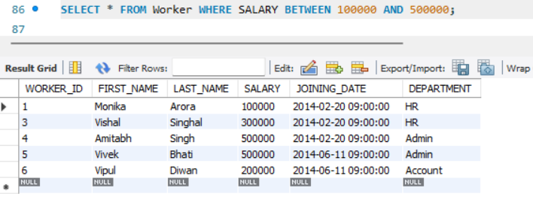

20.Ans:

SELECT * FROM Worker WHERE JOINING_DATE BETWEEN '2014-02-01' AND '2014-02-28';

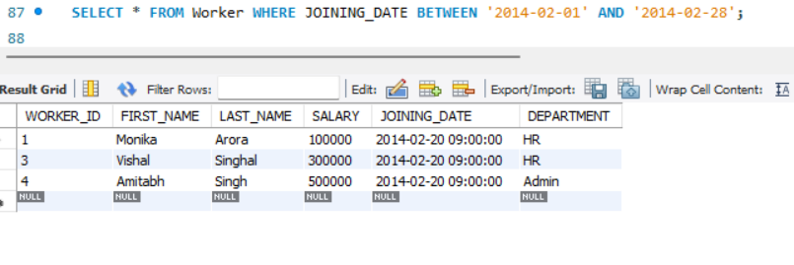

21.ANS:

SELECT COUNT(*) FROM Worker WHERE DEPARTMENT = 'Admin';

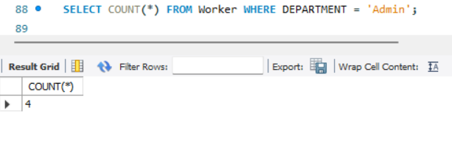

22.ANS:

SELECT FIRST_NAME FROM Worker WHERE SALARY >= 50000 AND SALARY <> 100000;

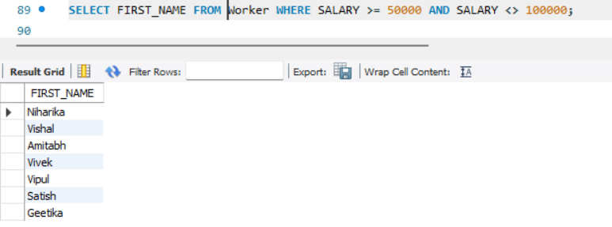

23.ANS:

SELECT DEPARTMENT, COUNT(*) AS WorkerCount FROM Worker GROUP BY DEPARTMENT ORDER BY WorkerCount DESC;

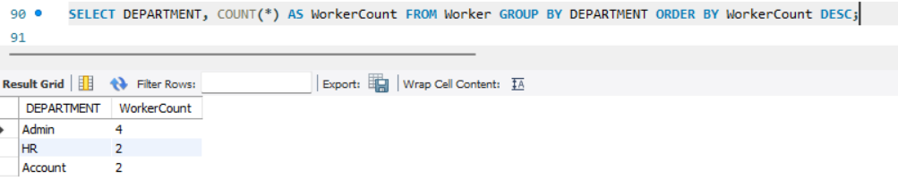

24.ANS:

SELECT * FROM Worker WHERE WORKER_ID IN (SELECT WORKER_REF_ID FROM Title WHERE WORKER_TITLE = 'Manager');

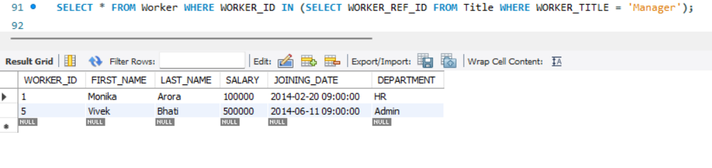

25.ANS:

SELECT FIRST_NAME, LAST_NAME, COUNT(*) FROM Worker GROUP BY FIRST_NAME, LAST_NAME HAVING COUNT(*) > 1;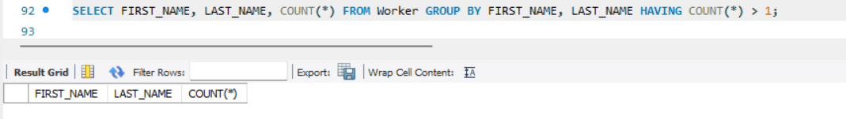

26.ANS:

SELECT * FROM (SELECT *, ROW_NUMBER() OVER (ORDER BY WORKER_ID) AS rownum FROM Worker) AS temp WHERE rownum % 2 = 1;

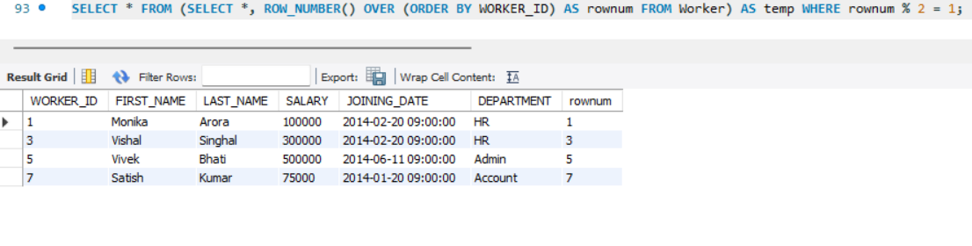

27.ANS:

SELECT * FROM (SELECT *, ROW_NUMBER() OVER (ORDER BY WORKER_ID) AS rownum FROM Worker) AS temp WHERE rownum % 2 = 0;

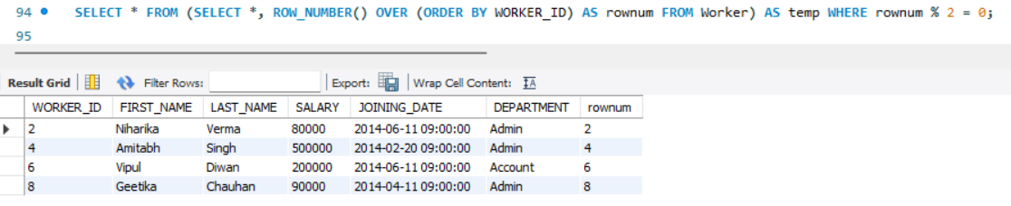

28.ANS:

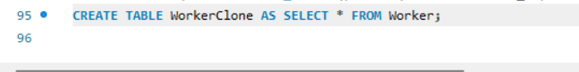

29.ANS:

SELECT *FROM Worker INTERSECT SELECT *FROM WorkerClone;

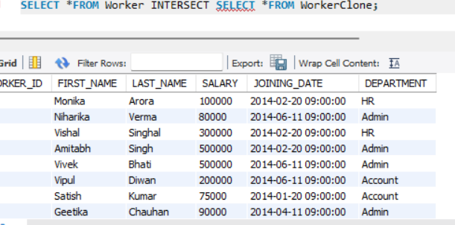

30.ANS:

SELECT * FROM Worker WHERE WORKER_ID NOT IN (SELECT WORKER_REF_ID FROM Bonus);

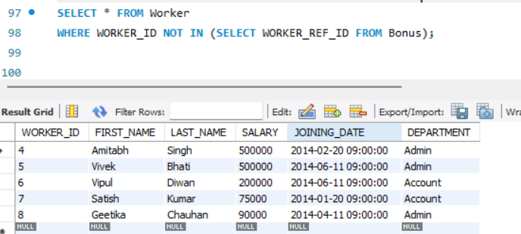

31.ANS:

SELECT CURRENT_TIMESTAMP;

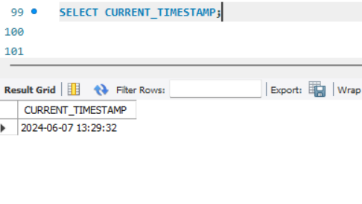

32.ANS:

SELECT * FROM Worker ORDER BY WORKER_ID LIMIT 10;

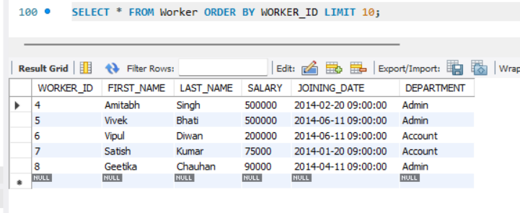

33.ANS:

SELECT DISTINCT SALARY FROM Worker W1 WHERE 5 = (SELECT COUNT(DISTINCT SALARY) FROM Worker W2 WHERE W2.SALARY >= W1.SALARY);

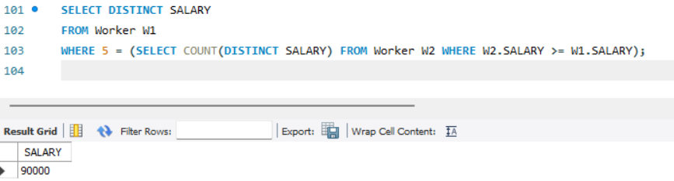

34.ANS:

SELECT MIN(SALARY) FROM (SELECT DISTINCT SALARY FROM Worker ORDER BY SALARY DESC LIMIT 5) AS subquery;

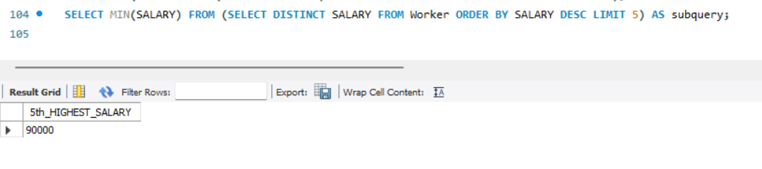

35.ANS:

SELECT SALARY, GROUP_CONCAT(FIRST_NAME) AS EMPLOYEES FROM Worker GROUP BY SALARY HAVING COUNT(*) > 1;

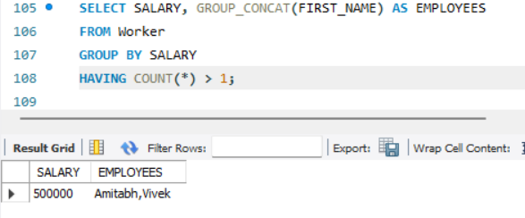

36.ANS:

SELECT MAX(SALARY) FROM Worker WHERE SALARY < (SELECT MAX(SALARY) FROM Worker);

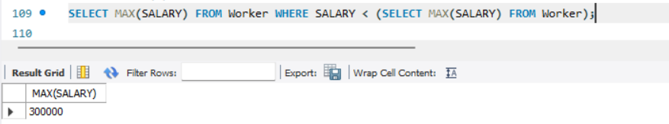

37.ANS:

SELECT * FROM Worker WHERE WORKER_ID = 1 UNION ALL SELECT * FROM Worker WHERE WORKER_ID = 1;

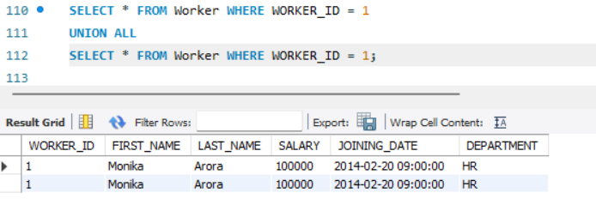

38.ANS:

SELECT * FROM Worker INTERSECT SELECT * FROM WorkerClone;

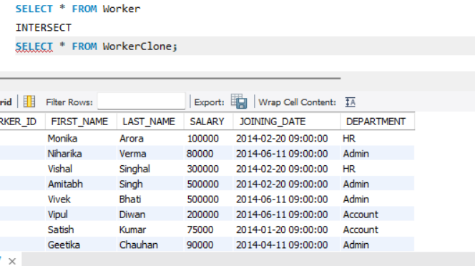

39.ANS:

SELECT * FROM WORKER WHERE WORKER_ID <= (SELECT count(WORKER_ID)/2 from Worker);

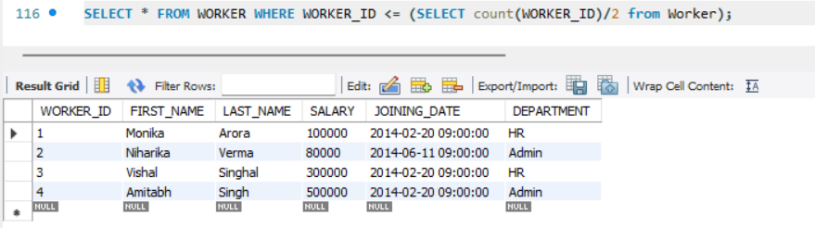

40.ANS:

SELECT DEPARTMENT FROM Worker GROUP BY DEPARTMENT HAVING COUNT(*) < 5;

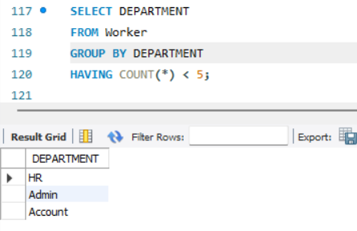

41.ANS:

SELECT DEPARTMENT, COUNT(*) AS NUMBER_OF_PEOPLE FROM Worker GROUP BY DEPARTMENT;

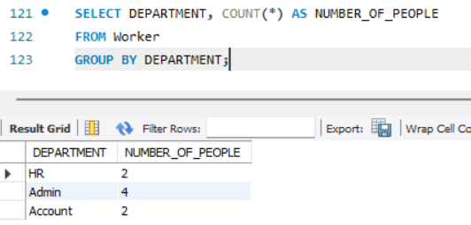

42.ANS:

SELECT * FROM Worker ORDER BY WORKER_ID DESC LIMIT 1;

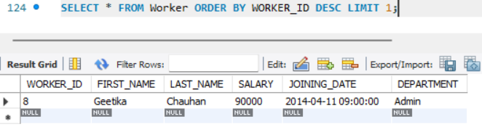

43.ANS:

Select * from Worker where WORKER_ID = (SELECT min(WORKER_ID) from Worker);

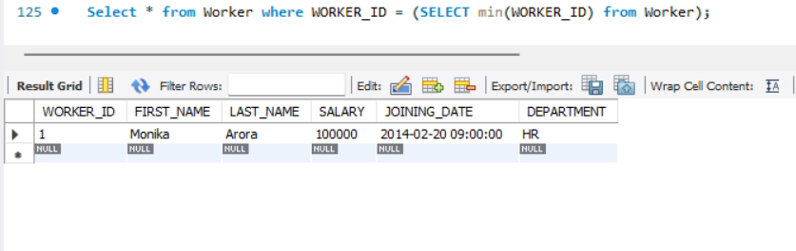

44.ANS:

SELECT * FROM Worker WHERE WORKER_ID <=5 UNION SELECT * FROM (SELECT * FROM Worker W order by W.WORKER_ID DESC) AS W1 WHERE W1.WORKER_ID <=5;

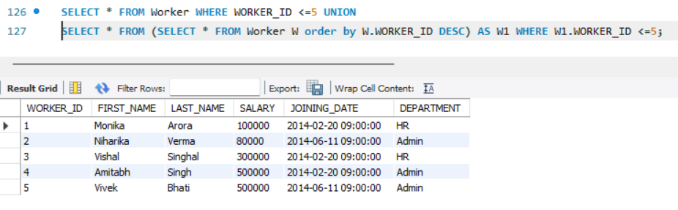

45.ANS:

SELECT DEPARTMENT, FIRST_NAME, LAST_NAME, SALARY FROM Worker w

WHERE SALARY = (SELECT MAX(SALARY) FROM Worker WHERE DEPARTMENT = w.DEPARTMENT);

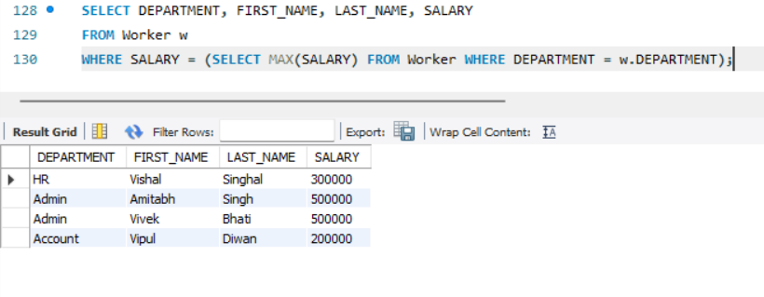

46.ANS:

SELECT DISTINCT SALARY FROM Worker ORDER BY SALARY DESC LIMIT 3;

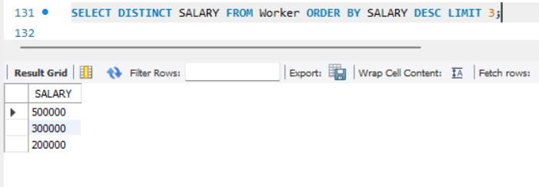

47.ANS:

SELECT DISTINCT SALARY FROM Worker ORDER BY SALARY LIMIT 3;

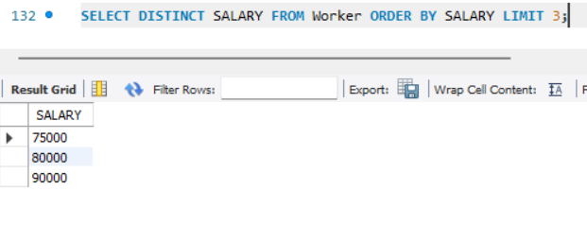

48.ANS:

SELECT DISTINCT SALARY FROM Worker W1 WHERE n = (SELECT COUNT(DISTINCT SALARY) FROM Worker W2 WHERE W2.SALARY >= W1.SALARY);

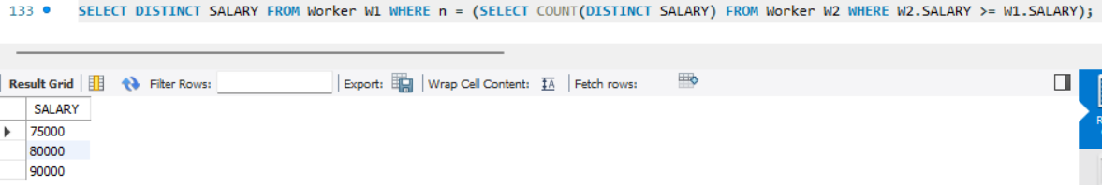

49.ANS:

SELECT DEPARTMENT, SUM(SALARY) AS TOTAL_SALARY FROM Worker GROUP BY DEPARTMENT;

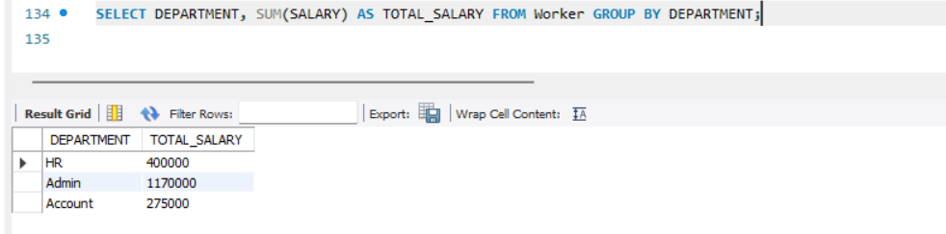

50.ANS:

SELECT FIRST_NAME, SALARY from Worker WHERE SALARY=(SELECT max(SALARY) from Worker);

